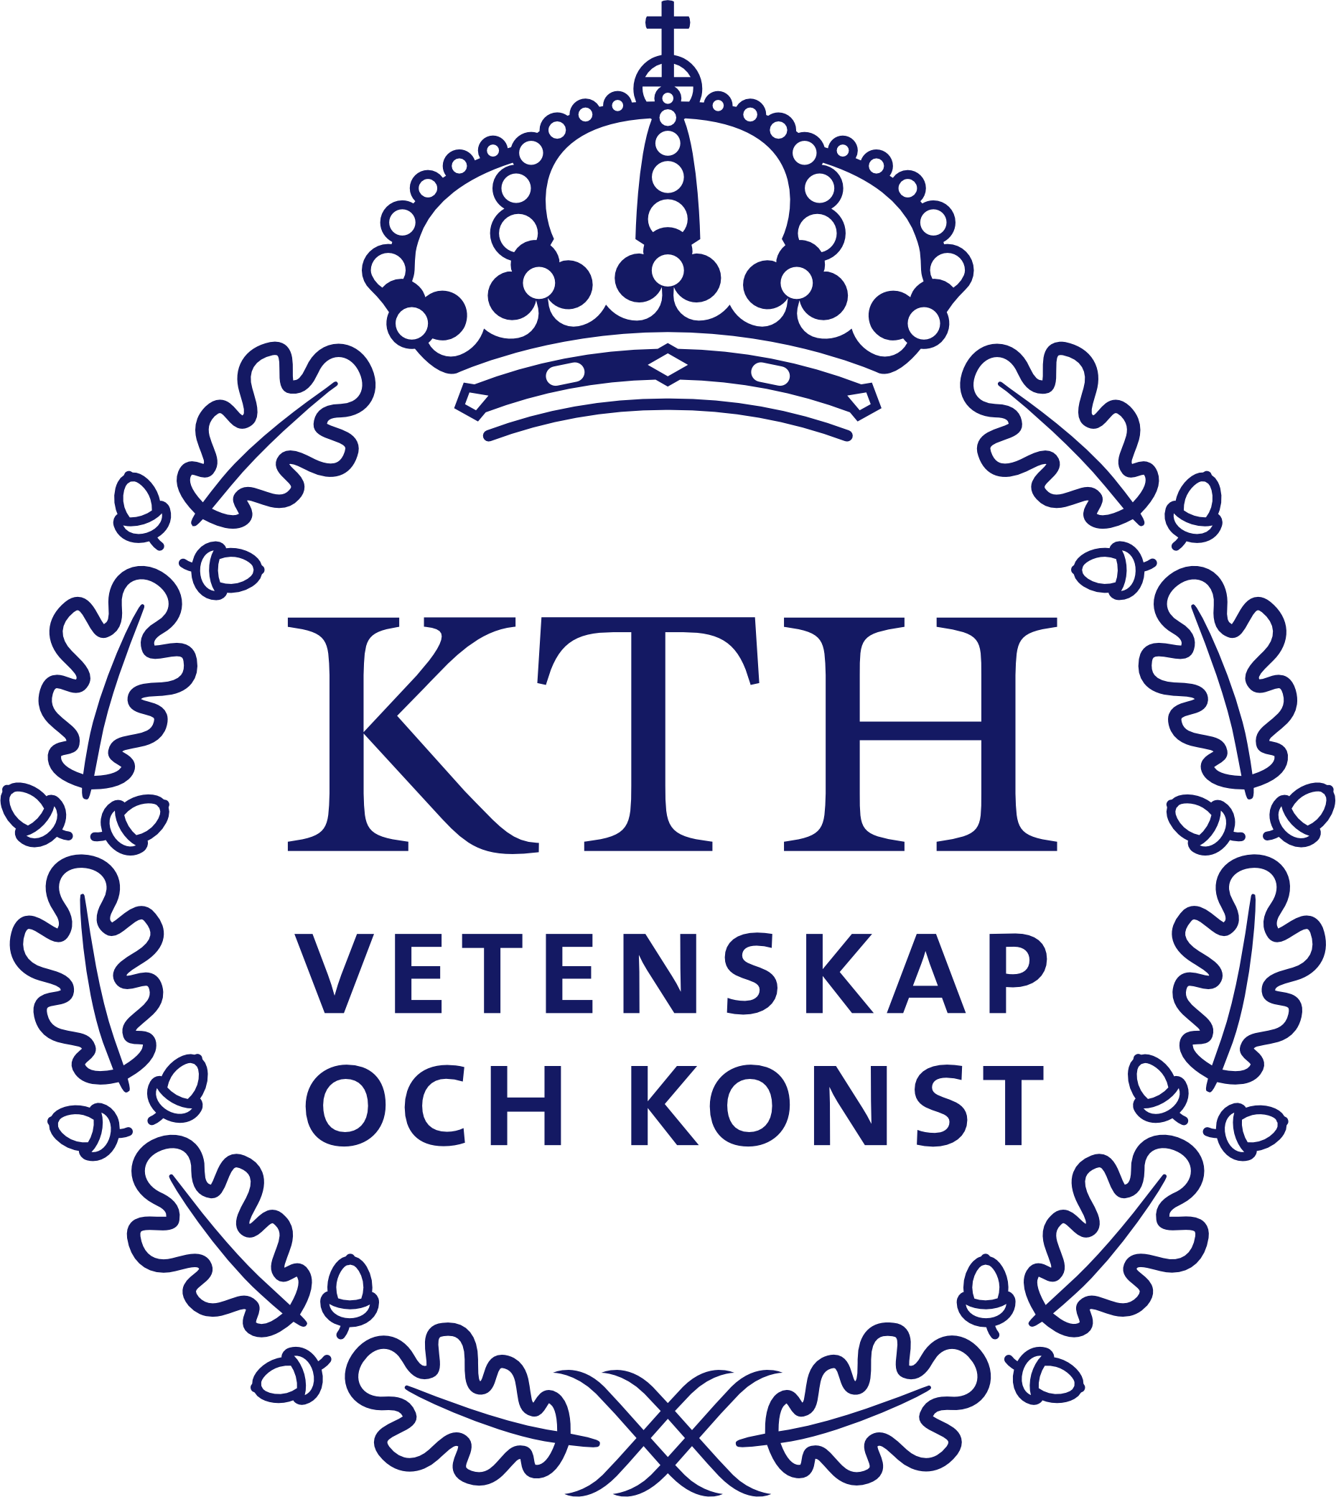

Course: Fibre Water Interactions

KTH Course FCK 3111
Course leaders: Prof. Lars Wågberg and Dr Per Larsson

Date: November 13–16, 2023
Place: KTH-Teknikringen 56

Principal lecturers:
Dr Tomas Larsson tomas.larsson@ri.se (TL)
Prof. Per Hansson per.hansson@ilk.uu.se (PH)
Prof. Lars Wågberg wagberg@kth.se (LW)
Dr Per Larsson perl5@kth.se (PL)
Dr Stefan Lindström stefan.lindstrom@miun.se (SL)
Dr Mikael Nygårds mikael.nygards@billerudkorsnas.com (MN)
Prof. Sören Östlund soren@kth.se (SÖ)
Dr Charlotta Hanson charlotta.hanson@essity.com (CH)
Prof. Agne Swerin agne.swerin@kau.se (AS)
Dr Lennart Salmén lsalmen@kth.se. (LS)

Monday, 13th of November, Rånby Room Time/lecturer
- Fibre, paper and water interactions: Problem specification, importance – New products  - Thermodynamics of water vapour adsorption to fibres  - Swelling of polyelectrolyte gels | 9–10 LW  10–12 TL  13–15 PH

Tuesday, 14th of November WWSC Conference room Time/lecturer
- Swelling of cellulose fibres  - Influence of fibre composition on moisture sorption  and fibre swelling  - Influence of moisture on mechanical properties of paper: Fibre and joint properties | 9–10 LW  10–12 LS  13–15 SÖ

Wednesday, 15th of November Rånby Room Time/lecturer
- Effect of moisture on the performance of cellulose-based films and cellulose-containing composites  - Dimensional stability of paper  - Wetting fundamentals  - Capillary penetration and superhydrophobicity – Fundamentals and applications | 9–10 PL  10–12 PL  13–15 AS  15-17 LW

Thursday, 16th of November WWSC Conference Room Time/lecturer
- Liquid absorption in hygiene products  - Influence of moisture on mechanical properties of paper and board  - Mechanosorptive effects in fibres, paper and cellulosic films | 8–10 CH  10–12 MN  13-15 SL

